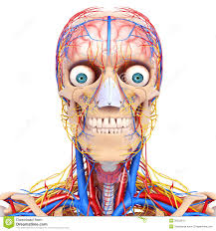
Notes for BODY SYSTEMS Chapter 5 Blue Book Name:______________________

Lesson 1: Body Organization
Learning Target: Describe how cells, tissues and organs work together.

1. The simplest and most basic unit of all living organisms is a _______________. A group of _________ working together to perform a single function is called a _______________. If you put two or more ___________ together you get an_________________. A group of _____________ working together to perform one function is called a __________________.

2. Explain why body systems depend on each other to perform their function properly.

Lesson 2: The Nervous System
Learning Target: Describe the different parts of the nervous system and some common problems as well.

- List the function of the nervous system on the chart attached to the back of this packet.
- List some of the organs of the nervous system on the chart attached to the back of this packet.
- Voluntary activity the brain controls__________________
- Involuntary activity the brain controls_________________
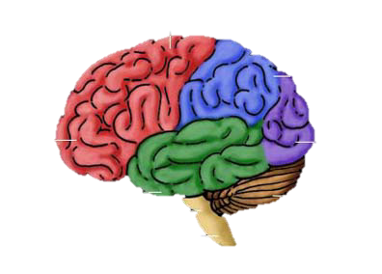
- The three parts of the brain include (also list the function of each part.)
  - _______________________________
  - _______________________________
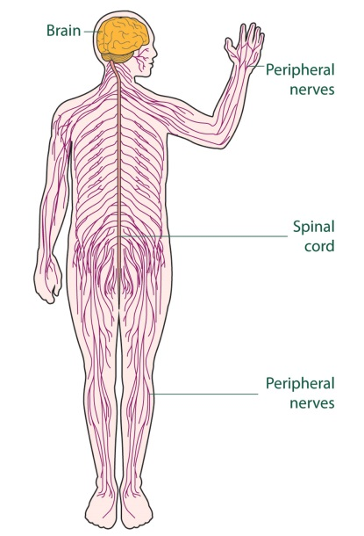
  - _______________________________

6. The CNS contains what two organs?

7. What makes up the Peripheral Nervous System and what is its function?

8. List some of the common problems of the Nervous System in the chart attached.

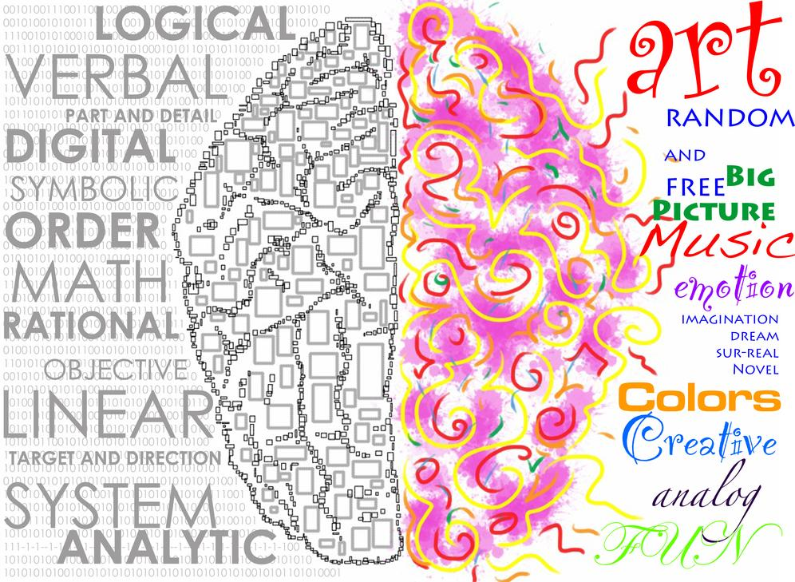
Are you right or left brained? Explain why.

Lesson 3: The Endocrine System
Learning Target: Identify different glans and their function and describe some common Endocrine System problems.

- List the function of the endocrine system on the chart attached to the back of this packet.
- List some of the organs of the endocrine system on the chart attached to the back of this packet.
- Glands in the endocrine system produce chemicals called _________________. List some examples of things these chemicals control.

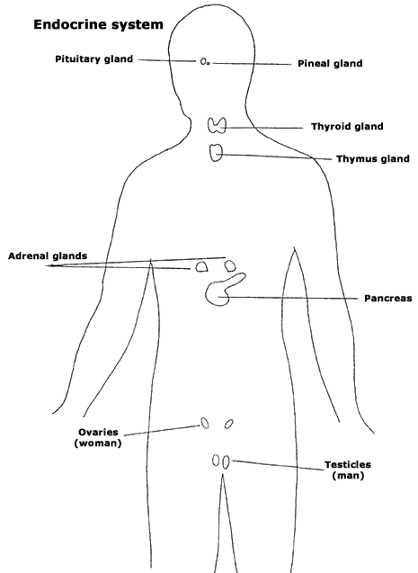
- Match the hormone to its function.
Testosterone_____ A. Stimulates the body in emergency
Estrogen____ situations.
Insulin____ B. Male hormone that stimulates sperm
Human growth hormone____ production.
Epinephrine_____ C. Stimulates body growth.
D. Regulates the amount of sugar in the
blood.
E. Female hormone.

5. List some of the common problems of the endocrine system in the
chart attached.
Lesson 4: Skeletal and Muscular Systems
Learning Target: Identify bones, muscle and joints of the body. Describe common problems of both systems and identify how muscles move the body.

- List the function of the skeletal system on the chart attached to the back of this packet.
- List some of the organs of the skeletal system on the chart attached to the back of this packet.
- Bone is made up of two types of tissue called 1._____________ 2.________________
- Soft flexible tissue called ______________ covers the ends of your bones.
- Inside your bone is a soft tissue called ______________ which makes what?
- A place where two or more bones connect is a ____________. List 3 types of these and where in the body you could find an example.
  - _________________________
  - _________________________
  - _________________________

- Ligaments connect_____________ to _____________.
- List some of the common problems of the skeletal system in the chart attached.
- List the function of the muscular system on the chart attached to the back of this packet.
- List some of the organs of the muscular system on the chart attached to the back of this packet.
- List the three types of muscles and where in the body you could find that type.
  - _____________________________
  - _____________________________
  - _____________________________
- Tendons connect ______________ to _____________.
- Explain how muscles cause movement.

- List some of the common problems of the muscular system in the chart attached.

Lesson 5: The Digestive and Urinary Systems
Learning Targets: Describe the process of digestion and waste removal. Describe common problems of this system.

- List the function of the digestive system on the chart attached to the back of this packet.
- List some of the organs of the digestive system on the chart attached to the back of this packet.
- Where does digestion begin? How?
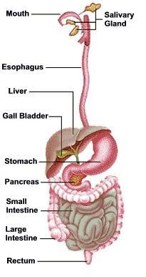
- The body uses energy for what 3 activities?

- List the 6 steps of digestion in order and describe what happens there.
  - _________________________________________
  - _________________________________________
  - _________________________________________
  - _________________________________________
  - _________________________________________
  - _________________________________________

- Why are fingerlike projects in the intestines important to the absorption of nutrients?

- List some of the common problems of the digestive system in the chart attached.

- List the function of the urinary system on the chart attached to the back of this packet.

- List some of the organs of the urinary system on the chart attached to the back of this packet.
- What are 3 ways your body eliminates waste?
  - ________________
  - ________________
  - ________________

- What is the function of a kidney? How many are most people born with?

- List some of the common problems of the urinary system in the chart attached.

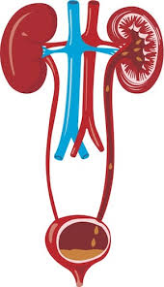

Lesson 6: Circulatory and Respiratory Systems
Learning Target: Describe the function of the two systems as well as some common problems of each.
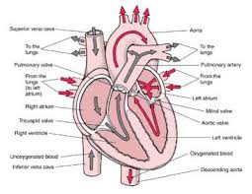
- List the function of the circulatory system on the chart attached to the back of this packet.
- List some of the organs of the circulatory system on the chart attached to the back of this packet.
- List the four parts of blood and their functions.
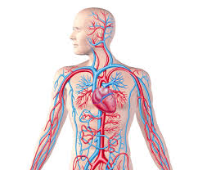
  - _____________________________________
  - _____________________________________
  - _____________________________________
  - _____________________________________

- What are the three types of blood vessels and their functions?
  - _____________________________________
  - _____________________________________
  - _____________________________________

- List some of the common problems of the circulatory system in the chart attached.
- List the function of the respiratory system on the chart attached to the back of this packet.
- List some organs of the respiratory system on the chart attached to the back of this packet.
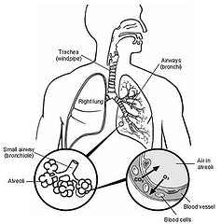
- Describe that path of air through the body.

- A dome-shaped muscle beneath the lungs that helps in breathing is called the ___________________. Tiny air sacs in the lungs are called _________________.

- List some common problems of the respiratory system on the attached sheet.

Lesson 7: Caring for Your Body
Learning Target: Describe six ways to protect your body systems

- List six tips for maintaining a healthy body.
  - ___________________________________
  - ___________________________________
  - ___________________________________
  - ___________________________________
  - ___________________________________
  - ___________________________________

