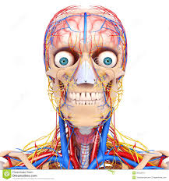
Notes for BODY SYSTEMS Chapter 5 Blue Book Name:______________________

Lesson 1: Body Organization
Learning Target: Describe how cells, tissues and organs work together.

1. The simplest and most basic unit of all living organisms is a cell. A group of cells working together to perform a single function is called a tissue If you put two or more tissues together you get an organ A group of organs working together to perform one function is called a body system.

2. Explain why body systems depend on each other to perform their function properly.
If one body system fails to do a job, it causes other body systems to shutdown.

Lesson 2: The Nervous System
Learning Target: Describe the different parts of the nervous system and some common problems as well.

- List the function of the nervous system on the chart attached to the back of this packet.
- List some of the organs of the nervous system on the chart attached to the back of this packet.
- Voluntary activity the brain controls movement and talking
- Involuntary activity the brain controls heartrate and breathing
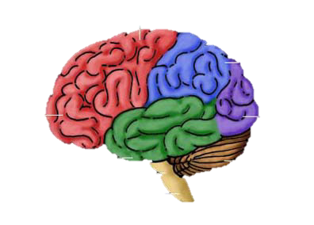
- The three parts of the brain include (also list the function of each part.)
  - Brainstem- breathing
  - Cerebrum- speech
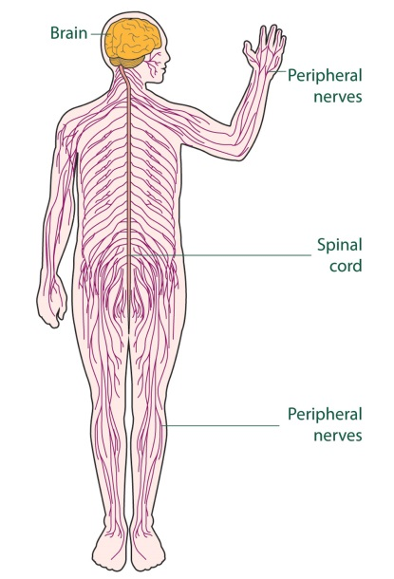
  - Cerebellum- balance

6. The CNS contains what two organs? Brain and spinal cord

7. What makes up the Peripheral Nervous System and what is its function?
Nerves, sends messages all of the body.
8. List some of the common problems of the Nervous System in the chart attached.

Lesson 3: The Endocrine System
Learning Target: Identify different glans and their function and describe some common Endocrine System problems.

- List the function of the endocrine system on the chart attached to the back of this packet.
- List some of the organs of the endocrine system on the chart attached to the back of this packet.
- Glands in the endocrine system produce chemicals called hormones List some examples of things these chemicals control. Growth and emotions

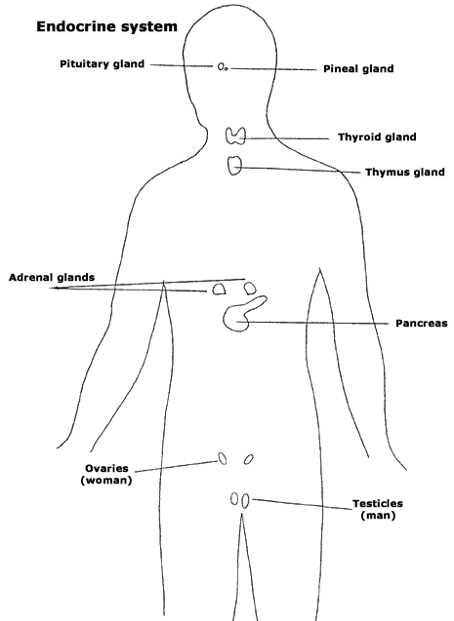
- Match the hormone to its function.
Testosterone B A. Stimulates the body in emergency
Estrogen E situations.
Insulin D B. Male hormone that stimulates sperm
Human growth hormone C production.
Epinephrine A C. Stimulates body growth.
D. Regulates the amount of sugar in the blood.
E. Female hormone.

5. List some of the common problems of the endocrine system in the
chart attached.
Lesson 4: Skeletal and Muscular Systems
Learning Target: Identify bones, muscle and joints of the body. Describe common problems of both systems and identify how muscles move the body.

Lesson 4: Skeletal and Muscular Systems
Learning Target: Identify bones, muscle and joints of the body. Describe common problems of both systems and identify how muscles move the body.

- List the function of the skeletal system on the chart attached to the back of this packet.
- List some of the organs of the skeletal system on the chart attached to the back of this packet.
- Bone is made up of two types of tissue called 1. Spongy bone 2. Compact bone
- Soft flexible tissue called cartilage covers the ends of your bones.
- Inside your bone is a soft tissue called bone marrow which makes what? Blood cells
- A place where two or more bones connect is a joint. List 3 types of these and where in the body you could find an example.
  - Hinge- elbow
  - Ball and socket- hip
  - Pivot- neck

- Ligaments connect bone to bone.
- List some of the common problems of the skeletal system in the chart attached.
- List the function of the muscular system on the chart attached to the back of this packet.
- List some of the organs of the muscular system on the chart attached to the back of this packet.
- List the three types of muscles and where in the body you could find that type.
  - Cardiac- heart
  - Skeletal- bicep
  - Smooth- intestines (internal organs)
- Tendons connect muscle to bone.
- Explain how muscles cause movement.
Tendons attach muscle to bone and then contract and relax to pull on bones.

- List some of the common problems of the muscular system in the chart attached.

Lesson 5: The Digestive and Urinary Systems
Learning Targets: Describe the process of digestion and waste removal. Describe common problems of this system.

- List the function of the digestive system to break down food.
- List some of the organs of the digestive system stomach, mouth, anus
- Where does digestion begin? How?
Mouth, saliva and teeth
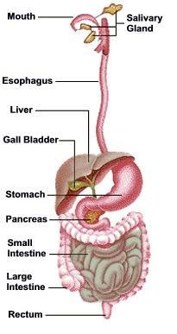
- The body uses energy for what 3 activities?
Growth, maintenance, repair

- List the 6 steps of digestion in order and describe what happens there.
  - Mouth-saliva and teeth
  - Esophagus
  - Stomach-mixes with juices
  - Small Intestines- digestion is finished and nutrients are absorbed into the blood.
  - Large Intestines- water and salt are absorbed
  - Anus- Waste leaves the body

- Why are fingerlike projects in the intestines important to the absorption of nutrients?
Villi help nutrients be absorbed into the blood.

- List some of the common problems of the digestive system Heartburn, diarrhea, constipation.

- List the function of the urinary system filter blood and rid the body of liquid waste

- List some of the organs of the urinary system kidney, bladder

- What are 3 ways your body eliminates waste?
  - Liquid waste/solid waste
  - Breathing
  - Sweating

- What is the function of a kidney? How many are most people born with?
The kidneys filter waste from the blood. 2

- List some of the common problems of the urinary system stone, Urinary tract infection

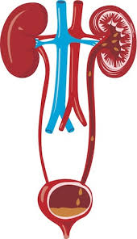

Lesson 6: Circulatory and Respiratory Systems
Learning Target: Describe the function of the two systems as well as some common problems of each.
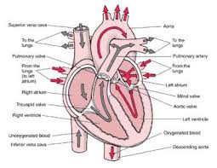
- List the function of the circulatory system Pumps blood.
- List some of the organs of the circulatory system heart, blood, blood vessels.
- List the four parts of blood and their functions.
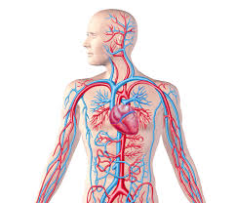
  - plasma-watery part of blood
  - Red blood cells- carry oxygen
  - White blood cells- fight infection
  - Platelets- clot blood

- What are the three types of blood vessels and their functions?
  - _____________________________________
  - _____________________________________
  - _____________________________________

- List some of the common problems of the circulatory system in the chart attached.
- List the function of the respiratory system to exchange carbon dioxide and oxygen, breathing.
- List some organs of the respiratory system mouth, nose, lungs
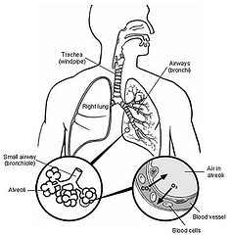
- Describe that path of air through the body.
Mouth/nose, pharynx, trachea, bronchi, lungs, bronchioles

- A dome-shaped muscle beneath the lungs that helps in breathing is called the diaphragm. Tiny air sacs in the lungs are called alveoli.

- List some common problems of the respiratory system asthma, lung cancer.

Lesson 7: Caring for Your Body
Learning Target: Describe six ways to protect your body systems

- List six tips for maintaining a healthy body.
  - ___________________________________
  - ___________________________________
  - ___________________________________
  - ___________________________________
  - ___________________________________
  - ___________________________________

